# How to Control Your Air Conditioner with Raspberry Pi Board and IR Remote Shield V1.0

1. IR Remote Shield V1.0 to Raspberry Pi Board

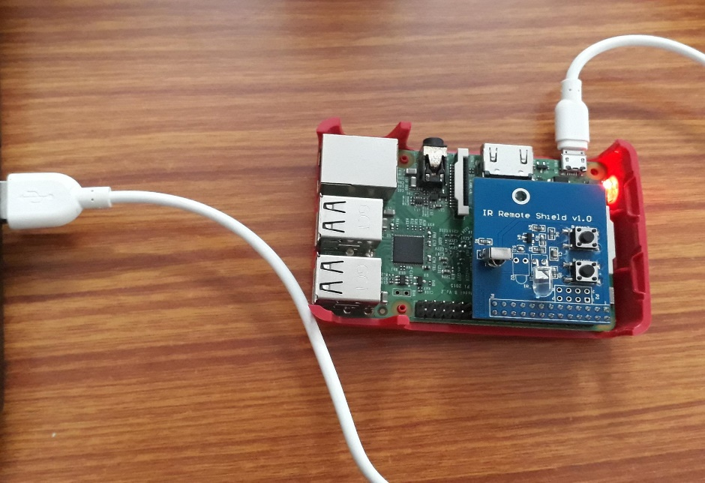

1. Getting lirc to work with Raspberry Pi 3

$ sudo apt-get update

$ sudo apt-get install lirc

# Add the following lines to /etc/modules file

lirc_dev

lirc_rpi gpio_in_pin=18 gpio_out_pin=17

# Add the following lines to /etc/lirc/hardware.conf file

LIRCD_ARGS="--uinput --listen"

LOAD_MODULES=true

DRIVER="default"

DEVICE="/dev/lirc0"

MODULES="lirc_rpi"

# Update the following line in /boot/config.txt

dtoverlay = lirc-rpi,gpio_in_pin=18,gpio_out_pin=17

# Update the following lines in /etc/lirc/lirc_options.conf

driver = default

device = /dev/lirc0

$ sudo /etc/init.d/lircd stop

$ sudo /etc/init.d/lircd start

# Check status to make lirc is running

$ sudo /etc/init.d/lircd status

# Reboot before testing

$ reboot

# To test if lirc driver is working

$ sudo /etc/init.d/lircd stop

$ mode2 -d /dev/lirc0

<press a key in remote and you should see multple lines like below>

pulse 560

space 1706

pulse 535

1. To record a custom remote/register a remote device

$ sudo /etc/init.d/lircd stop

$ mode2 –m –d /dev/lirc0 > on.conf

Then we need to edit our on.conf file manually:

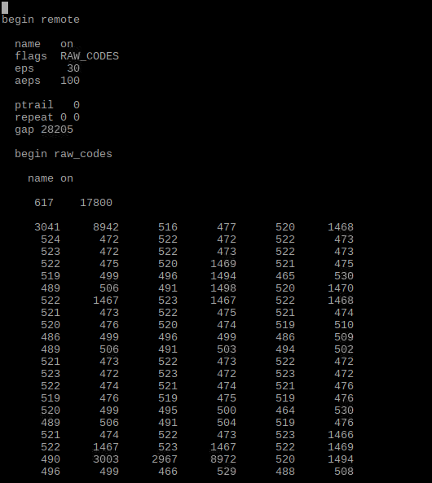

$ sudo cp on.conf /etc/lirc/lircd.conf

$ sudo /etc/init.d/lircd start

we can list the keys we’ve just defined in lircd.cong

$ irsend list “” “”

To turn on the AC:

$ irsend SEND_ONCE on on

|  |
| --- |
|  |
|  |
|  |
|  |
|  |

|  |
| --- |
|  |
|  |